**Creating Perspectives**

In this demo, you create an Internet Sales perspective. A perspective defines a viewable subset of a model that provides focused, business-specific, or application-specific viewpoints. When a user connects to a model by using a perspective, they see only those model objects (tables, columns, measures, hierarchies, and KPIs) as fields defined in that perspective.

The Internet Sales perspective you create in this lesson excludes the DimCustomer table object. When you create a perspective that excludes certain objects from view, that object still exists in the model. However, it is not visible in a reporting client field list. Calculated columns and measures either included in a perspective or not can still calculate from object data that is excluded.

The purpose of this lesson is to describe how to create perspectives and become familiar with the tabular model authoring tools. If you later expand this model to include additional tables, you can create additional perspectives to define different viewpoints of the model, for example, Inventory and Sales.

## **Creating Perspectives**

#### To create an Internet Sales perspective

1. Click the **Model** menu > **Perspectives** > **Create and Manage**.

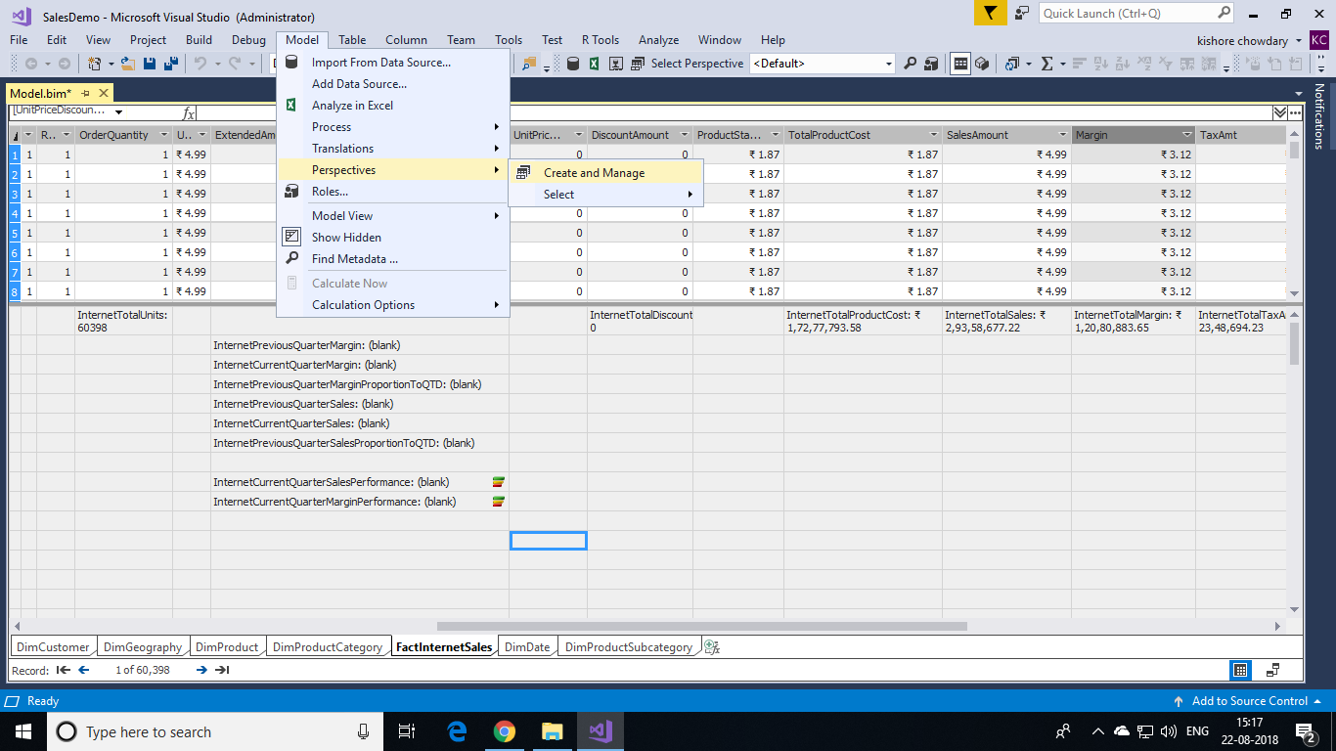

1. In the **Perspectives** dialog box, click **New Perspective**.
2. Double-click the **New Perspective** column heading, and then rename **Internet Sales**.
3. Select the all the tables except **DimCustomer**.

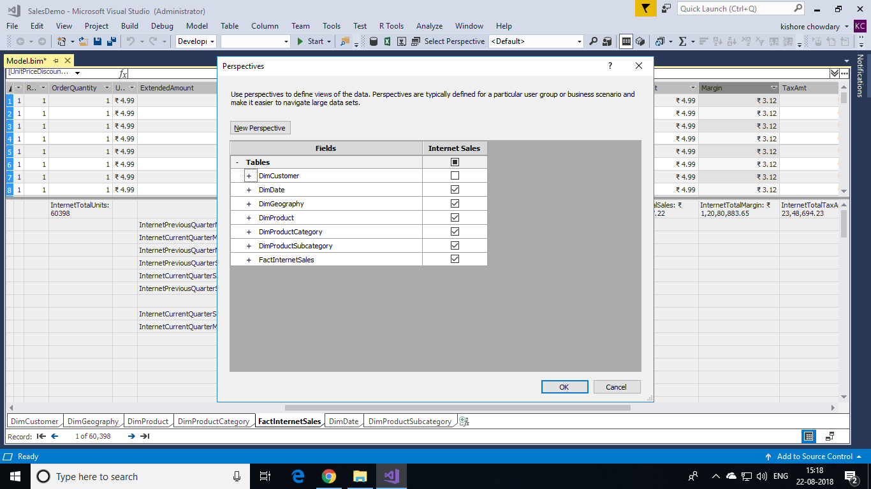

In a later part of the demos, you use the Analyse in Excel feature to test this perspective. The Excel PivotTable Fields List includes each table except the DimCustomer table.